COPING RESOURCES FOR STUDENTS

Ways to Calm ANXIETY
Sometimes you’ll need a quick way to calm Anxiety and you don’t have much with you. These tips will come in handy at those times:
- Imagine your favourite place - it’s like taking a mini vacation wherever you are
- Think of your favourite things
- Name animals alphabetically (alligator, bear, cow, dog, etc…)
- Squeeze Something (play dough, clay, silly putty, your fists, a stress ball)
- Get a Cold Drink of Water
- 54321 Grounding - go through each of your 5 senses

COPING SKILL SPOTLIGHT:

5, 4, 3, 2, 1 GROUNDING TECHNIQUE

HOW TO DO IT:
This technique will take you through your five senses to help remind you of the present. This is a calming technique that can help you get through tough or stressful situations.
Take a deep belly breath to begin.
5 - LOOK: Look around for 5 things that you can see, and say them out loud. For example, you could say, I see the computer, I see the cup, I see the picture frame.
4 - FEEL: Pay attention to your body and think of 4 things that you can feel, and say them out loud. For example, you could say, I feel my feet warm in my socks, I feel the hair on the back of my neck, or I feel the pillow I am sitting on.
3 - LISTEN: Listen for 3 sounds. It could be the sound of traffic outside, the sound of typing or the sound of your tummy rumbling. Say the three things out loud.
2 - SMELL: Say two things you can smell. It’s okay to move to another spot and sniff something. If you can’t smell anything at the moment or you can’t move, then name your 2 favourite smells.
1 - TASTE: Say one thing you can taste. It may be the toothpaste from brushing your teeth, or a mint from after lunch. If you can’t taste anything, then say your favourite thing to taste.
Take another deep belly breath to end.
- Give yourself a hug - squeeze tight!
- Remember the words to a song you love
- Do a hook up
- Put your arms straight out in front of you, palms facing out.
- Put one hand over the other at the wrists and interlace your fingers.
- Swoop your hands and arms toward your body and then place your interlaced hands on your chest.
- Cross your feet at the ankles and put your tongue on the roof of your mouth.
- Stay still for one minute.

Deep Breathing
It’s great to have a list of coping strategies to help with your anxiety. Here are two more short lists of ideas.
People usually roll their eyes initially when they hear “breathing is important”. But I will continue to say it and explain why. It’s so simple, yet has such a big impact on your body’s physiology.
When you and calm and relaxed, your body is in “rest and digest” mode. You breathe normally, your heart rate is lower and your muscles are relaxed. However, when stress or anxiety or anger occurs, your body automatically switches into “flight, fight or freeze” mode. Your muscles tense up, your heart rate increases and your breathing becomes more shallow.
Taking deep breaths, instead of shallow breaths, is one way to tell your body to get back to resting and digesting. That’s why deep breathing is important!
There are some fun ways to teach deep breathing techniques.Things to use
- Bubbles
- Feathers
- Pinwheels
- Dandelions
- Deep breathing using the shape below

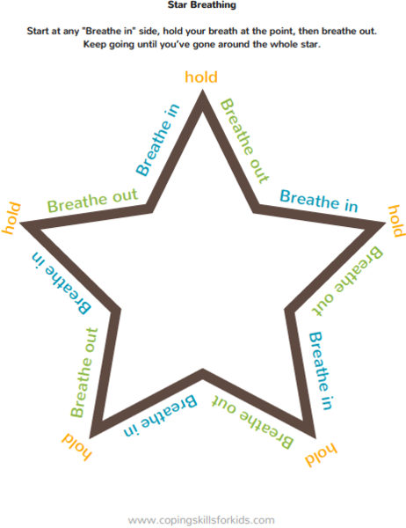
Things to say
- Breathe in like you are smelling a flower, breathe out like you are blowing out birthday candles
- Arms up and breathe in, arms down and breathe out

Pretend your stomach is a balloon. Breathe in and make the balloon bigger, then breathe out and make the balloon shrink

Create a ‘Calm Down’ Spot
You can create a place specially designed to allow you to calm down in a few steps
- Find a spot and make it cosy (place your favourite things in it like book, food, music, a blanket).
- Add calming tools e.g. mindfulness colouring pages
- Explain to others so they are aware of your calm down spot and tell them what you need e.g. them to talk to you or for you to be left alone or a hot/cold drink.
- When you feel the anxiety starting or escalating, try to catch it early and remember your calm down spot.

Use a Journal
Try writing a journal or diary about how you feel or writing one when you feel anxious. This helps you to process difficult thoughts and feelings and work through them. Journals help you to…
- Write about hard things if you find it hard to talk - it’s a release
- Journaling helps you process what’s happening.
- It’s convenient.
- It can help you solve a problem
- It can help you re-frame your thinking
Remember you’re not always going to feel like this and that your anxiety will pass. We all feel anxious at times and you’re not alone. Talk to someone about how you feel. There is help out there and if you feel you are unable to cope with the levels of anxiety you can always speak with your GP or the Samaritans.

Stay safe

