Tuition Fee Policy 2023/24

16-18 ESFA Funded Provision (Includes 19-24 year olds with EHCP)

Learners who are/will be 16, 17 or 18 on the 31st August in the calendar year when they begin a programme of study, will NOT pay tuition fees, registration fees or examination fees.

Where clothing or equipment is necessary for the student’s health or safety, a charge may be made for clothing and equipment that the student retains, but only if the student also has the option of borrowing the clothing or equipment free of charge.

In certain areas students will be encouraged to purchase their own kit, which they can take with them when they leave.

The College may charge for examinations and re-sits when funding criteria are met. A full set of charges rules in relation to 16-18 year old learners can be found in the ESFA Funding Guidance for Young People here:

https://assets.publishing.service.gov.uk/government/uploads/system/uploads/attachment_data/file/1147131/16_to_19_funding_guidance_Regulations_2023_to_2024-Final_Draft_1_AR_commsME__1_.pdf

Adult Education Provision - Classroom based

The devolution of adult education functions to specified combined authorities and the Mayor of London will apply in relation to the academic year from 1 August 2019. The following Combined Authorities will exercise, in relation to their area, certain adult education functions of the Secretary of State under the Apprenticeships, Skills, Children and Learning Act 2009.

- The Greater Manchester Combined Authority
- The Liverpool City Region Combined Authority
- The West of England Combined Authority
- The West Midlands Combined Authority
- The Tees Valley Combined Authority
- The Cambridgeshire and Peterborough Combined Authority

The College will be subject to different Adult Education Budget funding rules dependent on the residency of the learner.

EU, other EEA and Swiss nationals will no longer be eligible for ESFA funded adult education budget funding in England for courses starting in academic year 2021 to 2022. This will not affect students starting courses in academic year 2020 to 2021. It will also not apply to Irish nationals living in the UK or Ireland whose right to study and to access benefits and services will be preserved on a reciprocal basis for UK and Irish nationals under the Common Travel Area arrangement.
Adult Education Provision – resident of LCR (funded by LCRCA)

Learners unless otherwise agreed in writing with the Combined Authority. Learner postcodes can be checked for eligibility at https://www.gov.uk/find-local-council

https://api.liverpoolcityregion-ca.gov.uk/wp-content/uploads/2023/10/LCRCA-AEB-funding-rules-2023-to-2024-June-2023.pdf

The following is an extract from the Adult Education Budget performance - management rules funded by the LCRCA:

LCR AEB Contribution Table 1: Learners aged 19 to 23 year

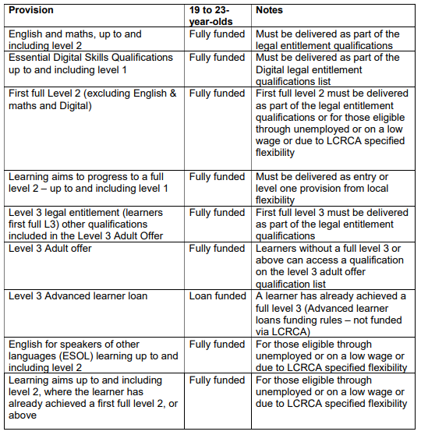

LCR AEB Contribution Table 2: Learners aged 24+
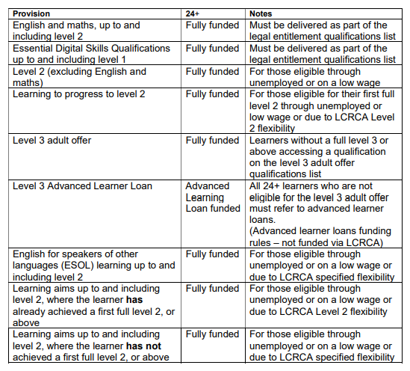
Exam fees
No exam fee to be charged as tuition fee is set at the maximum loan/weighted fee available. Fees may be charged for re-sits and/or retakes.

Kits and Uniforms
Basic kit and uniforms will be made available where applicable. In certain areas students will be encouraged to purchase their own kit, which they can take with them when they leave.
Unemployed status

For funding purposes, we define a Learner as unemployed if one or more of the following apply:
- They receive Jobseeker’s Allowance (JSA), including those receiving National Insurance credits only
- They receive Employment and Support Allowance (ESA)
- They receive Universal Credit, and their take-home pay as recorded on their Universal Credit statement (disregarding Universal Credit payments and other benefits) is less than £494 a month (learner is sole adult in their benefit claim) or £782 a month (learner has a joint benefit claim with their partner)
- They are released on temporary licence, studying outside a prison environment, and not funded by the Ministry of Justice
Low wage flexibility referred to must be eligible for co-funding and earns less than £31,600.40 annual gross salary.

Adult Education Provision – resident of non-devolved area (funded by ESFA)
The following is an extract from the Adult Education Budget performance - management rules funded by the ESFA:
Government contribution table 1: 19 to 23-year-
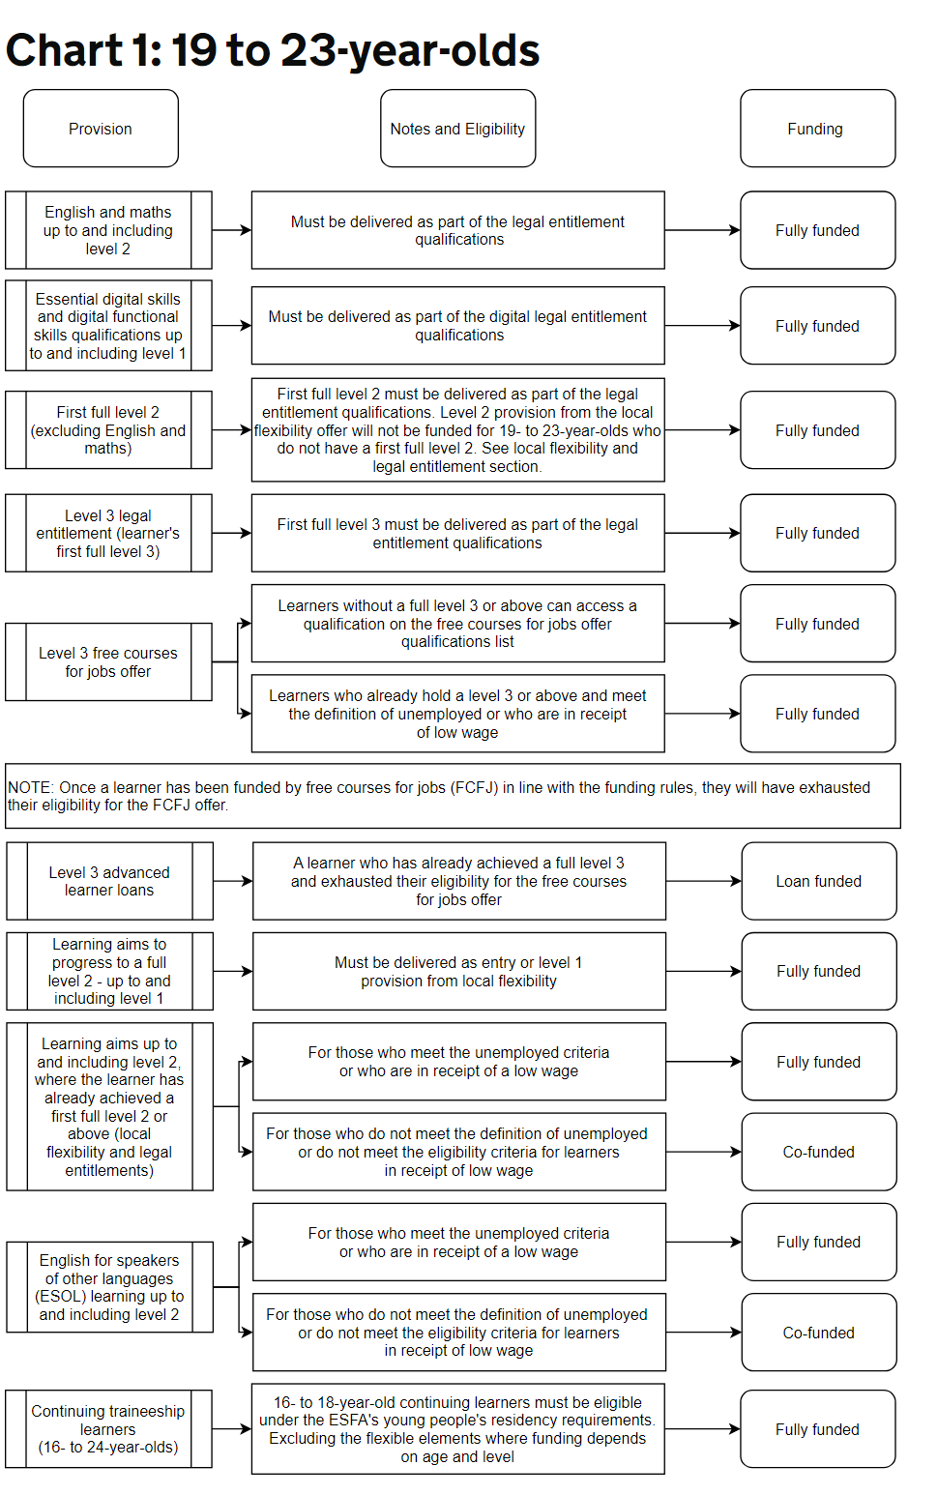
Government contribution table 2: 24+
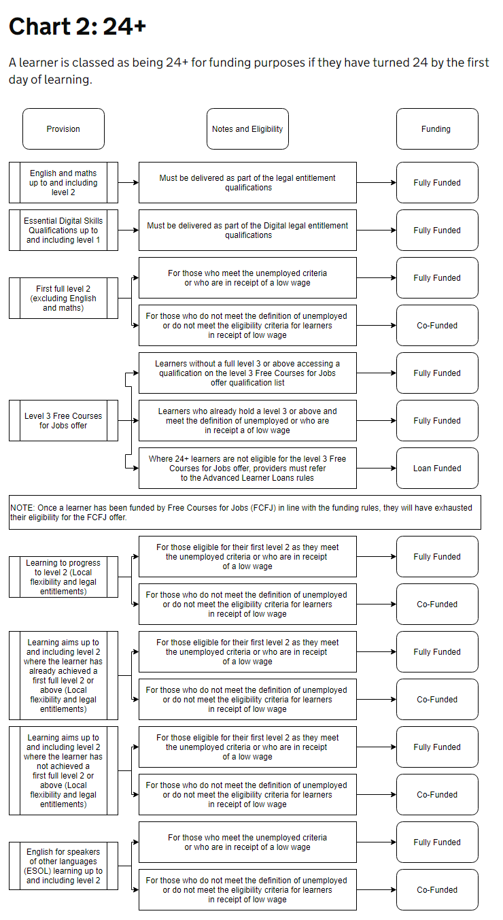
A full set of funding rules in relation to 19+ learners can be found in the ESFA funding guidance for Adult Education Budget: draft funding and performance- management rules here:

https://www.gov.uk/government/publications/adult-education-budget-aeb-funding-rules-2023-to-2024/esfa-funded-adult-education-budget-funding-rules-2023-to-2024

Low wage flexibility referred to must be eligible for co-funding and earns less than £20,319 annual gross salary.

Exam fees
No exam fee to be charged as tuition fee is set at the maximum loan/weighted fee available. Fees may be charged for re-sits and/or retakes.

Kits and Uniforms
Basic kit and uniforms will be made available where applicable. In certain areas students will be encouraged to purchase their own kit, which they can take with them when they leave.
Unemployed status

For funding purposes, ESFA define a learner as unemployed if one or more of the following apply, they:

- receive Jobseeker’s Allowance (JSA), including those receiving National Insurance credits only
- receive Employment and Support Allowance (ESA)
- receive Universal Credit (UC), and their take-home pay as recorded on their UC statement (disregarding UC payments and other benefits) is less than £617 a month (learner is sole adult in their benefit claim) or £988 a month (learner has a joint benefit claim with their partner)
- are released on temporary licence, studying outside a prison environment, and not funded by the Ministry of Justice
Adult Education Provision – resident of another devolved area
The College does not have a funding allocation for any other devolved area and therefore any adult learner from a devolved area would be unfunded and subject to a tuition fee.

The LCRCA has an arrangement for AEB Cross Border Learners with Greater Manchester Combined Authority however, this will be included in the main AEB allocation. This reciprocal arrangement does not apply to the National Skills Fund Level 3 Adult offer.

Higher Education fees
The Consumer Protection guidance for HEIs require that fees are must be set and published in good time for the marketing cycle therefore fees for 2024/25 are:
Full-Time Courses | 2023/24 | 2024/25
BA / BSc (3 years) FT - Year 1 | £8,400 | £8,400
BA / BSc (3 years) FT - Year 2 | £8,410 | £8,400
BA / BSc (3 years) FT - Year 3 | £8,278 | £8,410
BA / BSc Top up (1 year) FT | £8,400 | £8,400
Foundation Degrees- Year 1 | £8,300 | £8,300
Foundation Degrees -Year 2 | £8,278 | £8,300
HNC | £6,700  (except £7,400 for C&E*) | £6,700  (except £7,400 for C&E*)
HND – top up | £6,700  (except £7,400 for C&E*) | £6,700  (except £7400 for C&E*)
PGCE/PGDipE/Certificate in Education FT | £8,450 | £8,450

Part-time HE Courses | 2023/24 | 2023/24
PGCE/PGDipE/Certificate in Education PT - Year 1 | £4,200 | £4,200
PGCE/PGDipE/Certificate in Education PT- Year 2 | £4,205 | £4,200
Foundation Degree Dental Technology (3 year) - Year 1 | £5,600 | £5,600
Foundation Degree Dental Technology (3 year) - Year 2 | £5,607 | £5,600
Foundation Degree Dental Technology (3 year) - Year 3 | £5,519 | £5,607
HNC (2 year) - Year 1 | £3,350  (except £3,700 for C&E*) | £3,350  (except £3,700 for C&E*)
HNC (2 year) - Year 2 | £3,338  (except £3,698 for C&E*) | £3,350  (except £3,700 for C&E*)
BA/BSc Top up (2 years) PT – Year 1 | £4,200 | £4,200
BA/BSc Top up (2 years) PT – Year 2 | £4,205 | £4,200

* C&E is Construction and Engineering. The higher rate applies to all programmes in these subject areas only.

HE bursaries are offered subject to eligibility criteria.

In future years we anticipate increasing the fees in line with the annual inflation level (capped at RPI All Items Excluding Mortgage Interest (RPIX)).

For EU students with settled or pre-settled status and Irish citizens, the rate is the same as the Home Fees. The College does not currently offer courses for international students, including those from Europe, who require a visa to study in the UK.

The College does not currently offer courses for international students outside the EU. For students from within the EU, the rate is the same as the Home Fee.

Apprenticeship Provision

 | 2023/24
Employer Fees for Apprenticeships (non-levy paying employers) | Employers will be required to pay 5% of the cost of apprenticeship training with the government paying the remaining 95%
Employer Fees for Apprenticeships (levy paying employers) | Employers will be required to pay for the apprenticeship training from their apprenticeship service account
Employer Fees for Apprenticeships (levy paying employers) who do not have enough funds in their apprenticeship service account | Employers will be required to pay 5% of the cost of apprenticeship training with the government paying the remaining 95%

Managing Agents (Indirect Apprenticeships)

 | 2023/24
Infill | All 2023/24 new starts will be agreed on a case by case basis by the Executive team. It is expected that the Training Provider will pay the College 80% of the funding received for the competences being delivered.

Schools Provision

 | 2023/24
Discrete group (hourly rate) | Schools – Minimum of £140 per hour (plus materials & exams); however, the College reserves the right to negotiate rates with individual schools
Infill (per hour) aged 14-19 | Minimum of £10 per hour; however, the College reserves the right to negotiate rates with individual schools
Alternative Provision | As specified in the Alternative Provision contract with Liverpool City Council
Additional learning support | Specific rates to be determined based on students’ identified needs.

Other Charges

Other Charges | 2023/24
Income Generation Activities | Refer to list of fees for specific courses
Additional learning support for students on IG courses | Specific fees to be determined based on students’ identified needs.
Adult Safeguarded Learning | Refer to list of fees for specific courses
ID card replacement (staff and students) | £2 (one replacement card per annum provided free of charge)
Instalments  Threshold at which payment by instalments is available (subject to terms and conditions) | Course fee in excess of £250 and course duration over 12 weeks
Instalment administration fee | £12.50 +VAT
Private candidates | Examination fee plus administrative fee

Instalment arrangements for students paying their own fees

ESFA Funded courses, Income Generation and HE:

Instalment offer is subject to students meeting the terms and conditions.

For enrolments taking place in September on a 1 year course, up to 8 instalments and up to 15 instalments for 2 year courses. The number of instalments decreases depending on the date of enrolment and length of course

First instalment is due at enrolment. See “Student Payment of Course Fees” document for further details

NB: For learners experiencing financial difficulties, it may be possible to make payment arrangements with Financial Services via automated collection from learner’s debit / credit cards.

In certain circumstances, the College may remove the option to pay by instalments when there is a risk that non-recovery of fees may result in the course not being financially viable. The Deputy Chief Executive is delegated to approve an amendment where it makes commercial sense to do so.

Apprenticeship fees

Employers should be encouraged to pay the full amount up front. Where instalments are requested the following will apply:

- For apprenticeships up to 2 years’ duration, employer contributions will be taking in two instalments with 50% upfront and 50% at three months.
- For apprenticeships of 2 years or more, employer contributions will be taken in multiple instalments with 50% upfront and the balance of the remaining 50% split into equal parts and taken at the beginning of each remaining year.

If a learner withdraws, the college will retain the first 50% of the employer contribution. The employer will be refunded the remaining 50% contribution pro rata over the duration of the framework.

The Deputy Chief Executive is delegated to approve an amended payment schedule where it makes commercial sense to do so.

Fee reassessment/refund

Fees are refundable in full if the College cancel the course.

In certain circumstances, students may be eligible for a refund/reassessment of the fee which is documented in the College Fee Reassessment / Refund. The student must complete the Student Application Form and in line with the policy, the College may authorise a refund for a proportionate amount of the tuition fee applicable to the remaining classes of the course which the student will be unable to attend.

A copy of the College Fee Reassessment / Refund procedure is available upon request from the Finance Department.

