

**Further Education Positive Behaviour Framework (14+)**

**Amended September 2023**

|  |
| --- |
| Approved |
|  |
|  |
|  |

# Summary of Contents

1. Framework Overview
2. Procedure
3. Student Conduct Procedure Overview
4. Stages of Warning
   1. Intervention
   2. Stage 1
   3. Stage 2
   4. Stage 3
   5. Stage 4
   6. Suspension
   7. Dismissal
   8. Appeals

# Framework Overview

# Aim

This framework applies to all students studying at the City of Liverpool College (CoLC) on face-to-face programmes as well as for digital and remote learning.

The aim is to set out a clear framework to promote positive behaviours amongst all students, that are industry focussed to make our students more employable and to maintain the safety and well-being staff, students and stakeholders at all times. This framework supports students working both on site, within an Apprenticeship within a business, digitally and when representing the College externally.

Policy Statement

The City of Liverpool College has high expectations of all students with high standards for how they conduct themselves within the college and work environment. We believe that positive behaviours should be promoted to develop the skills, knowledge and behaviours that will be required within the workplace. The framework promotes and embeds the core values of the College, which is committed to preparing our students beyond qualification.

The Positive Behaviour Framework works alongside the Professional Standards, produced by staff and student representatives, to describe the standards of work and behaviour that we expect. This is made available to students within their Welcome Pack, available on ‘My Hub’ and delivered as part of the PDP in college during the ‘Preparation for Learning’ phase. Positive behaviour is promoted by all College staff at all times, in the classrooms, workshops, salons and kitchens and in corridors and communal spaces, as well as when students are representing the college externally. Individual courses may have additional expectations, for example those linked to professional practice. These are set out clearly in the Course Guide, or in other written instructions from College staff, such as those relating to work placement.

All students have a responsibility to behave in an appropriate and employment focussed manner showing respect for others, good manners and politeness to all, as well as adhering to health and safety guidelines and regulations.

Staff at the College have a responsibility to challenge inappropriate behaviours that go against our Professional Standards or breach Health and Safety guidelines, and to follow this positive behaviour framework to address such behaviours. The emphasis is on supporting students to understand why expected behaviours should be followed and to put supportive measures in place to promote more positive actions.

In most cases, the positive behaviour framework will be followed stage by stage. In some cases it may be necessary to move to higher stages straight away due to the nature of the behaviour.

Where appropriate, students who receive a warning will be referred to pastoral support services such as counselling, mental health support, finance etc. Every effort will be made to support students to address behaviour in order to avoid escalation and ensure that they achieve.

1. Procedure

The steps within the Student Conduct Procedure are as follows:

|  |  |
| --- | --- |
| Intervention Meetings | Tutor or Any Staff member |
| STAGE 1: Informal Verbal Warning | Tutor, Progress leader or appropriate staff member |
| STAGE 2: Formal Verbal Warning | Deputy/Assistant, Head of School or Head of Student Progress |
| STAGE 3: Written Warning | Head of School/Dean of Academic Studies/Head of Student Progress |
| STAGE 4: Final Written Warning | Director or Head of Faculty |
| Dismissal | Director |

Stages may be missed, depending on the nature of behaviour and students do not have to start on a Stage 1 and work their way up to a Stage 4. The member of staff issuing the warning will decide on the level depending on the behaviour.

Students can be suspended at any stage and the level of sanction issued will be decided following an investigation (further information below)

Intervention

Intervention meetings and classroom management instructions are the first part of the positive behaviour procedure, and meetings and subsequent actions set on ProMonitor may be designed to mitigate the risk of a further staged warning being required.

Classroom management and intervention meetings are used to address behaviours such as the following:

* failure to follow instructions
* non-participation in group tasks
* deliberate missed assignment deadlines
* disruptive or unacceptable behaviour
* using a mobile phone in class (when not permitted)
* using Social Media/inappropriate websites not related to tasks by tutor

The Tutor and/or Progress Leader will discuss conduct with the student. This will be recorded as a Learner Meeting on the student ILP on ProMonitor, with SMART targets set for improvement.

1. Positive Behaviour Framework

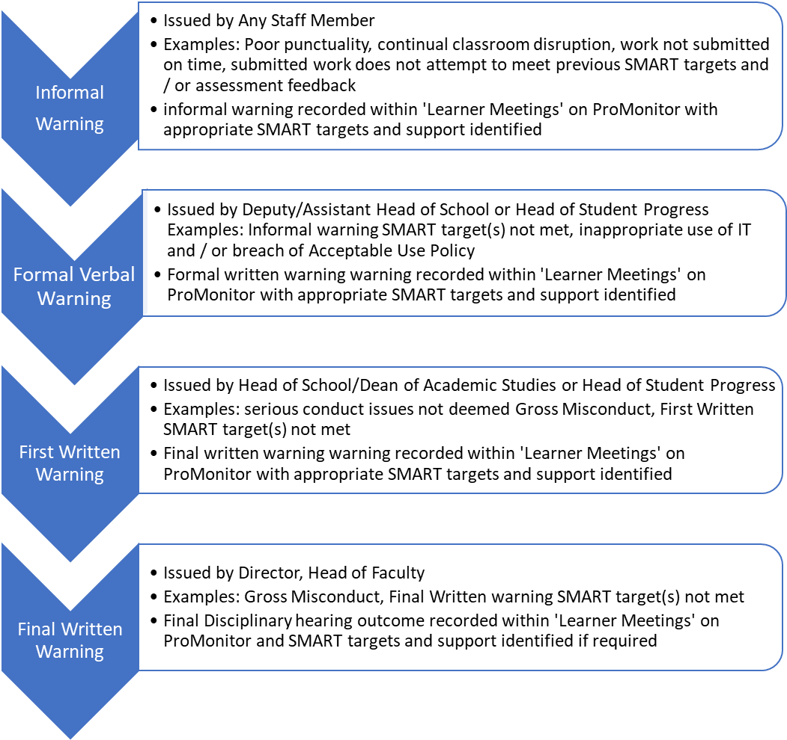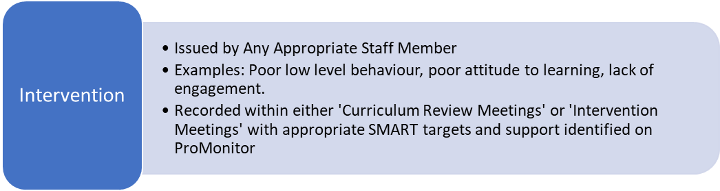

A student can be suspended at any stage and the level of sanction issued (if appropriate) will be decided following an investigation

1. Stages of Warning

4.1 Stage 1 – Informal Verbal Warning

**Responsibility:** Appropriate member of college staff

A Stage 1 is issued when there is a breach of the Professional Standards and there has been no improvement following an Intervention Meeting.

The member of staff will meet with the student and discuss the behaviour with the student. This will be recorded as a Learner Meeting on the student ILP on ProMonitor, with SMART targets set for improvement and agreed by the student. A monitoring meeting may be arranged to review behaviour after an agreed timescale.

If appropriate, referrals to pastoral support will be agreed within the Informal Warning meeting.

A letter will be sent home informing the student (and Parent/Guardian where the student is 14-18) of the warning.

4.2 Stage 2 – Formal Verbal Warning

**Responsibility:** Deputy/Assistant Head of School or Head of Student Progress

A Stage 2 may be issued when there has been no improvement following a Stage 1 meeting and the targets set previously have not been met.

It may also be issued as a first warning for a student if the behaviour displayed warrants that level of warning, this could include (but not limited to), disrespectful behaviour shown towards other students or members of staff, misuse of IT Policy, misuse of tools/equipment, continued refusal to engage in classroom activities.

The Deputy/Assistant Head of School or Head of Student Progress will meet with the student and discuss the behaviour with the student. This will be recorded as a Learner Meeting on the student ILP on ProMonitor, with SMART targets set for improvement and agreed by the student. A monitoring meeting may be arranged to review behaviour after an agreed timescale.

If appropriate, referrals to pastoral support will be agreed within the Informal Warning meeting.

A letter will be sent home informing the student (and Parent/Guardian where the student is 14-18) of the warning.

4.3 Stage 3 – First Written Warning

**Responsibility:** Head of School, Dean of Academic Studies or Head of Student Progress

A Stage 3 may be issued when there has been no improvement following a Stage 2 Warning and the targets set previously have not been met.

It may also be issued as a first warning for a student if the behaviour displayed warrants that level of warning, this could include (but not limited to), threats made to staff or students, bullying and/or discrimination, breach of the Equality Policy, breach of health and safety, breaking the rules of an awarding body such as copying someone else's work, suspected drug or alcohol use in or around College buildings

The Head of School, Dean of Academic Studies or Head of Student Progress will meet with the student and discuss the behaviour with the student. This will be recorded as a Learner Meeting on the student ILP on ProMonitor, with SMART targets set for improvement and agreed by the student. A parent/guardian may be invited in for the Stage 3 meeting. A monitoring meeting may further be arranged to review behaviour after an agreed timescale.

If appropriate, referrals to pastoral support will be agreed within the Informal Warning meeting.

4.4 Stage 4 – Final Written Warning

**Responsibility:** Director, Head of Faculty

A Stage 4 may be issued when there has been no improvement following a Stage 3 Warning and the targets set previously have not been met.

It may also be issued as a first warning for a student if the behaviour displayed warrants that level of warning, this could include (but not limited to), theft, attempted theft or unauthorised possession of any items belonging to the College, any student or employee, serious damage deliberately caused or attempted to College property, violent, dangerous, abusive, intimidating or indecent behaviour e.g. fighting, threats, deliberately breaking the College's health and safety rules, intentional breach of the College's Equality Policy, e.g. harassing or abusing another student, member of staff or a visitor to the College.

The Director or Head of Faculty will meet with the student and discuss the behaviour with the student. This will be recorded as a Learner Meeting on the student ILP on ProMonitor, with SMART targets set for improvement and agreed by the student. A parent/guardian will be invited in for the Stage 4 meeting.

A monitoring meeting may further be arranged to review behaviour after an agreed timescale. Should behaviour not have improved, the Director may dismiss the student from College.

Students (16-18) who are dismissed will automatically be referred to relevant support service (Appendix 9). If a student has a learning difficulty and/or disability with an EHCP, the referral applies up to the age of 25. If the student is care experienced and/or is in public care the referral applies up the age of 18 but the Care Experienced Lead must be contacted to ensure the relevant support service is contacted.

4.5 Suspension

The College reserves the right to suspend a student if the student’s actions seriously challenge the health, safety or welfare of other students or members of staff. A suspension can be given at any point within the Positive Behaviour Framework.

Any member of staff can suspend a student. The member of staff must remove the badge from the student and inform them of the following:

* a suspension is a neutral act and does not attribute any form of guilt on the student
* All parties involved will be suspended
* A student is suspended in order to remove them from the situation and allow for us to understand what has happened and to avoid any repercussions. It is used to protect all parties.
* It provides the opportunity to investigate the incident.
* A manager will be assigned to investigate and will complete a review of the incident, take accounts from people involved/witnesses and possibly review CCTV
* The student must not discuss the incident or accusation with anyone involved or any other student as this could jeopardise the investigation and result in all students involved being excluded due to the investigation having been compromised.

The member of staff will also be responsible for informing parent/guardian of the suspension, liaising with the relevant admin to ensure meetings are arranged and letters sent and to record the suspension on ProMonitor.

A suspension may be imposed where an accusation of poor behaviour has been made and a decision for a suitable outcome needs to be investigated. Examples include (but are not limited to) bullying or cyber bullying, harassment of any kind, gross misconduct, fighting, threatening behaviour, being under the influence of alcohol or drugs, damage of college resources, inappropriate behaviour

Students will be invited in for a Suspension Meeting (Appendix 4 – Letter) to review the accusation and present evidence that has been found during the investigation, within 7 working days of the suspension. Where this is not possible due to a complex investigation contact must be made to all students involved to explain the delay. This meeting will be chaired by a Director.

Following on from the Suspension Meeting, there can be three possible outcomes:

* After reviewing the investigation report there is no behaviour issue to answer, and all suspensions are lifted, the student returns to College.
* After reviewing the investigation report it is found that a particular level of sanction is needed, and an action plan should be put in place.
* After reviewing the investigation report it is found that a dismissal is appropriate.

The suspension hearing meeting should be recorded on pro-monitor in the meeting section. Where relevant, a referral to the Welfare and Well-being team will be made to support the students.

4.6 Dismissal

**Responsibility:** Director

Following a Suspension Meeting or Stage 4 Meeting and having considered all of the evidence presented by both staff and students (and their representatives) plus any witness statements submitted, dismissal may be the decided outcome. This will be communicated to the student and (parent/guardian if 14-18) both verbally and in writing.

The College will always offer to refer the student onto one of our partner organisations to further support the student into a positive outcome.

The College will not allow the student to re-enrol until the period of the dismissal has passed. This is likely to minimum of one academic year.

The College reserves the right to take the reason for the dismissal into consideration when deciding, after the period of dismissal has passed, whether the person meets the requirements of the College’s Admissions Policy.

4.7 Appeal

Where students have been issued with a Stage 4 or Dismissal, they have the right to appeal in writing to an identified Director or Vice Principal Curriculum Development and Innovation within 10 working days. Students will be informed of who to address their appeal to as this will be a different member of staff than the Head of School, Director, Head of Faculty or Dean of Academic Studies who conducted the Stage 4 or Suspension Meeting. The student will then be invited in for an Appeals Hearing (Appendix 7) where the action taken will be reviewed and a final decision taken.

There are three grounds for appeal:

1) the procedures set out in this document have not been followed or

2) the student has new evidence about the case or

3) the student believes the decision reached is unfair or unreasonable.

The appeal will be considered by the Director or Vice Principal (CDI) who will decide the next course of action. If they decide an appeal hearing is required, the student will be able to state their case and can bring another person along (e.g. parent/carer). Legal representation is not allowed.

At the appeal for dismissal, the terms of dismissal will be reviewed. When the hearing is complete, and after considering all the evidence, the person leading the hearing will state his/her decision. The panel may decide:

* To overturn the Final Disciplinary Warning / dismissal decision
* to vary the terms of the Final Disciplinary Warning / dismissal, for example by replacing the student’s Final Disciplinary Warning / dismissal with a lower level warning
* to uphold the Final Disciplinary Warning/ Dismissal.

The decision of the College Panel appointed to hear the appeal will be given to the student in writing within five working days of the appeal hearing and will be final and binding



Appendices

Appendix 1 Professional Standard

Appendix 2A Stage 1 Letter (14-18)

Appendix 2B Stage 1 Letter (19+)

Appendix 3A Stage 2 Letter (14-18)

Appendix 3B Stage 2 Letter (19+)

Appendix 4A Stage 3 Letter (14-18)

Appendix 4B Stage 3 Letter (19+)

Appendix 5A Stage 4 Letter (14-18)

Appendix 5B Stage 4 Letter (19+)

Appendix 6A Suspension Letter (14-18)

Appendix 6B Suspension Letter (19+)

Appendix 7A Dismissal Letter (14-18)

Appendix 7B Dismissal Letter (19+)

Appendix 8 Investigation Report template

# Appendix 1: Professional Standards

**Professional Standards**

The College aims to provide a safe and supportive environment where everyone can study and work to the best of their ability. Enrolment onto a course means you have joined the College community and are expected to behave in a professional way at all times that is employment focussed. You have agreed to this by signing the enrolment form.

What we will do for you:

* Treat you with courtesy and respect in line with College values
* Promote the College values of respect for others, rule of law and tolerance of differences so as to create an inclusive and respectful environment which values and celebrates individual differences.
* Ensure that the College is a safe, healthy and supportive place to learn for everyone
* Agree a learning programme which suits your needs and goals
* Provide an induction into College
* Give you information about assessments at the beginning of your course
* Tell you about additional costs such as course materials and visits
* Tell you how to get study support (English, maths and language support or support for a learning difficulty and/or disability)
* Start your lessons on time
* Provide you with personal support through reviews
* Provide you with appropriate and impartial careers advice and guidance
* Offer enrichment activities to help you develop your personal, social and employability skills so that you are able to become an active member of the community
* Keep accurate records of your progress and share these with you regularly
* Return your marked work in timescales set out in your Course Guide
* Ask you what you think about your course and other aspects of college life
* Tell you what we have done as a result of your comments
* Invite you to get involved in College decision-making.

What we expect from you:

* To follow instructions given by a member of College staff or someone acting for the College (such as a work placement supervisor)
* To notify your tutor if your absence is longer than a week. We will assume you have left if you have been absent without explanation for 4 term time weeks.
* To keep to the Acceptable Use Policy when using college computers (available under ‘Information’ on the Student Intranet)
* To let your personal tutor know straight away if you have difficulties with your work
* To give your name and ID number to any member of staff who asks for it
* To notify your local centre office if you are absent
* To achieve the standard of work required of you
* To treat other students and staff with respect
* To hand all assignments in on time
* To attend all classes and tutorials
* To be punctual.

We will not accept:

* Unacceptable behaviour in or around college buildings. Examples of unacceptable behaviour include insulting others, bullying, verbal abuse or rudeness, using language which offends others, fighting or other violent, threatening or dangerous behaviour
* Action which could be seen as harassment of a fellow student or member of staff (for definition of harassment, see the Equality section in the Student Handbook)
* Promoting or celebrating extremist views that go against the College values of inclusiveness, respect for others, tolerance and rule of law
* Abuse, threats or rudeness to a member of staff.  These may be verbal or sent electronically, for example through Facebook
* The use of illegal drugs or alcohol in or near college buildings
* Damage deliberately caused to college property or seriously attempted damage to college property
* Theft, attempted theft or unauthorised possession of any items belonging to the college or to any student, member of staff or employer
* Breaking the rules of an awarding body, such as copying someone else’s work
* Repeated problems with the quality of work produced or of handing it in on time, affecting your own or other students’ chances of gaining accreditation. This may be because of delays in producing work which affects a group project
* Disruptive behaviour in classes, LRCs or other college spaces, or not following a direct instruction from a member of staff.

# Appendix 2A: Stage 1: Informal Verbal Warning (14-18)

Date: [written in letter format] e.g. 5th September 20--

Parent/Carer of

Students Name

Address

Area

Postcode

Student Full Name:

Student ID:

Dear Parent/Carer of [Name]

I am writing to inform you that [Name] has been issued with a Stage 1 informal verbal warning for:

**Reason**:

**Smart Targets set**:

There are 4 stages to the College’s Student Conduct Policy & Procedure, which can be found on the student intranet (www.my.liv-stu.co.uk). Printed copy enclosed. We expect an immediate improvement in order to avoid any further disciplinary action and appropriate actions have been set to support this. Support and guidance from College staff is available to help prevent further issues.

Please contact **[Staff full name]** on 0151 252 ---- if you would like to discuss this matter further.

Yours sincerely

[Staff initial surname]

Subject Tutor/Progress Leader

# Appendix 2B: Stage 1: Informal Verbal Warning (19+)

Date: [written in letter format] e.g. 5th September 20--

Students Name

Address

Area

Postcode

Student Full Name:

Student ID:

Dear [Name]

I am writing to inform you that you have been issued with an Stage 1 informal verbal warning for:

**Reason**:

**Smart Targets set**:

There are 4 stages to the College’s Student Conduct Policy & Procedure, which can be found on the student intranet (www.my.liv-stu.co.uk). Printed copy enclosed. We expect an immediate improvement in order to avoid any further disciplinary action and appropriate actions have been set to support this. Support and guidance from College staff is available to help prevent further issues.

Please contact **[Staff full name]** on 0151 252 ---- if you would like to discuss this matter further.

Yours sincerely

[Staff initial surname]

Subject Tutor/Progress Leader

# Appendix 3A: Stage 2: Formal Verbal Warning (14-18)

Date: [written in letter format] e.g. 5th September 20--

Parent/Carer of

Full Name

Add

Area

Postcode

Student Full Name:

Student ID:

Dear Parent/Carer of [student name]

I am writing to inform you that [Name] has been issued with a Stage 2 Formal verbal warning for:

**Reason**:

**Smart Targets set**:

There are 4 stages to the College’s Student Conduct Policy & Procedure, which can be found on the student intranet (www.my.liv-stu.co.uk). Printed copy enclosed. This is **stage two** of the policy. We expect an immediate improvement in order to avoid any further disciplinary action. Support and guidance from College staff is available to help prevent further issues.

Please contact **[Staff full name]** on 0151 252 ---- if you would like to discuss this matter further.

Yours sincerely

[Staff initial surname]

Deputy Head of School/Head of Student Progress

# Appendix 3B: Stage 2: Formal Verbal Warning 19+

Date: [written in letter format] e.g. 5th September 20--

Full Name

Add

Area

Postcode

Student Full Name:

Student ID:

Dear [Name]

I am writing to inform you that you have been issued with a stage 2 formal verbal warning for:

**Reason**:

**Smart Targets set**:

There are 4 stages to the College’s Student Conduct Policy & Procedure, which can be found on the student intranet (www.my.liv-stu.co.uk). Printed copy enclosed. This is **stage two** of the policy. We expect an immediate improvement in order to avoid any further disciplinary action. Support and guidance from College staff is available to help prevent further issues.

Please contact **[Staff full name]** on 0151 252 ---- if you would like to discuss this matter further.

Yours sincerely

[Staff initial surname]

Deputy Head of School/Head of Student Progress

# Appendix 4A: Stage 3: First Written Warning 14-18 years

Date: [written in letter format] e.g. 5th September 20--

Parent/Carer of

Full Name

Add

Area

Postcode

Student Full Name:

Student ID:

Dear Parent/Carer of [student name]

I am writing to inform you that [Name] has been issued with a Stage 3 First Written warning for:

**Reason**:

**Smart Targets set**:

There are 4 stages to the College’s Student Conduct Policy & Procedure, which can be found on the student intranet (www.my.liv-stu.co.uk). Printed copy enclosed. This is **stage three** of the policy. We expect an immediate improvement in order to avoid any further disciplinary action. Support and guidance from College staff is available to help prevent further issues.

Please contact **[Staff full name]** on 0151 252 ---- if you would like to discuss this matter further.

Yours sincerely

[Staff initial surname]

Head of School / Head of Student Progress

# Appendix 4B: Stage 3: First Written Warning 19+

Date: [written in letter format] e.g. 5th September 20--

Full Name

Add

Area

Postcode

Student Full Name:

Student ID:

Dear [Name]

I am writing to inform you that you have been issued with a Stage 3 first written warning for:

**Reason**:

**Smart Targets set**:

There are 4 stages to the College’s Student Conduct Policy & Procedure, which can be found on the student intranet (www.my.liv-stu.co.uk). Printed copy enclosed. This is **stage three** of the policy. We expect an immediate improvement in order to avoid any further disciplinary action. Support and guidance from College staff is available to help prevent further issues.

Please contact **[Staff full name]** on 0151 252 ----] if you would like to discuss this matter further.

Yours sincerely

[Staff initial surname]

Head of School / Head of Student Progress

**Appendix 5A: Stage 4: Final Written Warning (14-18)**

Date: [written in letter format] e.g. 5th September 20--

Full Name

Add

Area

Postcode

Student Full Name:

Student ID:

Dear Parent/Carer of [student name]

I am writing to inform you that [Name] has been issued with a Stage 4 final written warning for:

**Reason**:

**Smart Targets set**:

There are 4 stages to the College’s Student Conduct Policy & Procedure, which can be found on the student intranet (www.my.liv-stu.co.uk). Printed copy enclosed. This is **stage three** of the policy. We expect an immediate improvement in order to avoid any further disciplinary action. Support and guidance from College staff is available to help prevent further issues.

Please contact **[Staff full name]** on 0151 252 ----] if you would like to discuss this matter further.

Yours sincerely

[Staff initial surname]

Head of School / Head of Student Progress

**Appendix 5B: Stage 4: Final Written Warning 19+**

Date: [written in letter format] e.g. 5th September 20--

Full Name

Add

Area

Postcode

Student Full Name:

Student ID:

Dear [Name]

I am writing to inform you that you have been issued with a Stage 4 final written warning for:

**Reason**:

**Smart Targets set**:

There are 4 stages to the College’s Student Conduct Policy & Procedure, which can be found on the student intranet (www.my.liv-stu.co.uk). Printed copy enclosed. This is **stage three** of the policy. We expect an immediate improvement in order to avoid any further disciplinary action. Support and guidance from College staff is available to help prevent further issues.

Please contact **[Staff full name]** on 0151 252 ----] if you would like to discuss this matter further.

Yours sincerely

[Staff initial surname]

Head of School / Head of Student Progress

# 

# Appendix 6A: Suspension 14-18

Date: [written in letter format] e.g. 5th September 20--

Parent/Carer of

Full Name

Add

Area

Postcode

RE: **Suspension–** Student full Name – ID number

Dear Parent/Carer of Name

I am writing to inform you that [name] has been **suspended** from college**,** pending an investigation. A suspension is when we ask students not to attend College for a period of time, to protect the student and allow for us to understand what has happened and to avoid any repercussions.

We would like you to attend a suspension meeting with [Name] [Title] and [Name] [Head of Student Progress] on [**Day] [Date] at [time] in room [number]** at [Centre name], Address so we can discuss the incident and decide on a suitable outcome. Possible outcomes include:

1. Return to College with no further action
2. Return to College and be issued a Warning in line with the Positive Behaviour Framework
3. Dismissal from College (with a referral on to support onto something positive)

While [name] is suspended, we would ask that they not to come into any of the College buildings or to discuss the suspension or related matters with any other students, as this may impact on the investigation.

A copy of the Student Conduct Policy and Procedure is enclosed for reference purposes.

If you do not attend this meeting, this could result in Dismissal from College.Please call to reception on arrival.

Please contact me on 0151 252 ---- if you would like to discuss this matter further.

Yours sincerely

*Insert signature*

*Name - Title*

# Appendix 6B: Suspension 19+

Date: [written in letter format] e.g. 5th September 20--

Full Name

Add

Area

Postcode

RE: **Suspension–** Student full Name – ID number

Dear

I am writing to inform you that you have been **suspended** from college**,** pending an investigation. A suspension is when we ask students not to attend College for a period of time, it is to protect the student and allow for us to understand what has happened and to avoid any repercussions.

We would like you to attend a suspension meeting with [Name] [Title] and [Name] [Head of Student Progress] on [**Day] [Date] at [time] in room [number]** at [Centre name], Address so we can discuss the incident and decide on a suitable outcome. Possible outcomes include:

1. Return to College with no further action
2. Return to College and be issued a Warning in line with the Positive Behaviour Framework
3. Dismissal from College (with a referral on to support onto something positive)

While you are suspended, we would ask that you do not to come into any of the College buildings or to discuss the suspension or related matters with any other students, as this may impact on the investigation.

A copy of the Student Conduct Policy and Procedure is enclosed for reference purposes.

If you do not attend this meeting, this could result in Dismissal from College.Please call to reception on arrival.

Please contact me on 0151 252 ---- if you would like to discuss this matter further.

Yours sincerely

*Insert signature*

*Name - Title*

# Appendix 7A: Dismissal Letter (14-18)

Date: [written in letter format] e.g. 7th September 20--

*Parent/Carer of*

Full Name

Add

Area

Postcode

RE: **Dismissal** – Full Name – ID number

Dear Parent/ Carer/ of [Name]

Following the suspension meeting [insert meeting date], I am writing to inform you of the outcome of the investigation. After considering all the evidence carefully it has now been decided that [student’s name] should be dismissed from the College.

The reasons that we have come to this decision are listed below:

No further applications from [student’s name] to enrol as a student will be considered before [insert date of following academic year September 20--].

You have the right to appeal this decision within 10 working days of the date of this letter. Appeals must be sent in writing directly to [Appeal Director’s Name] at the following address:

[Appeal Director’s Name & Title]

The City of Liverpool College

[Centre Address]  
 Liverpool

[Postcode]

Yours sincerely,

[Signature]

Director Name - Title

# Appendix 7B: Dismissal Letter (19+)

Date: [written in letter format] e.g. 7th September 20--

*Parent/Carer of*

Full Name

Add

Area

Postcode

RE: **Dismissal** – Full Name – ID number

Dear [Name]

Following the suspension meeting [insert meeting date], I am writing to inform you of the outcome of the investigation. After considering all the evidence carefully it has now been decided that you should be dismissed from the College.

The reasons that we have come to this decision are listed below:

No further applications from you to enrol as a student will be considered before [insert date of following academic year September 20--].

You have the right to appeal this decision within 10 working days of the date of this letter. Appeals must be sent in writing directly to [Appeal Director’s Name] at the following address:

[Appeal Director’s Name & Title]

The City of Liverpool College

[Centre Address]  
 Liverpool

[Postcode]

Yours sincerely,

[Signature]

Director Name - Title

# Appendix 8: Investigation Report Template



**Confidential Student Investigation Case**

**Student name, Student ID**

**Investigating Officers:**

Contents

Introduction 26

Background 26

Investigation 26

Conclusions & Recommendation 26

Follow on investigation 26

# Introduction

# Background

# Investigation

# Conclusions & Recommendation

# Follow on investigation

**Appendices**