Further Education Student Performance
Policy and Procedure
Amended September 2023

Summary of Contents

- Policy Overview
- Student Profile and Individual Learning Plan
- Monitoring Student Attendance
- Settling in Period (Preparation for Learning)
- Progress Boards
- On Track meeting
- Special Consideration
- Vulnerable Students
- Key Roles and Responsibilities

1. Policy Overview

This policy is to support students and staff in providing a learning environment at the City of Liverpool College (COLC) whereby everyone is fully aware of the expectations of the performance of students, to help them to achieve their own academic goals and develop as individuals during their course of study.

This Student Performance Policy (SPP) is to be considered in conjunction with the Positive Behaviour Framework (SCP) and Progress Boards (PB). The aim is to support each student at the start of their academic year and throughout the duration of their chosen course(s), monitoring their progress during the first 6 weeks of their college journey (Preparation for Learning) and throughout the remainder of the college year. The policy provides clear guidelines on how staff can effectively follow up on concerns around a student’s ability to achieve on their course and to identify and manage supportive measures which can be put in place to ensure students remain, achieve and progress to a positive destination.

A key point of this policy is to have the right approach to supporting all students who want to study at the College by building expectations at the very start of their course(s) around attendance and performance and not to wait until later in the course when this may be more difficult to develop and maintain.

It is expected that across the College, most students will not be drawn into this Policy as they will have good attendance, be on the correct course of study and be completing the class and course work at appropriate levels for their qualification(s) and that other college intervention has proven to have had a positive and effective outcome in getting the student back on track with their studies. This Policy applies to students in need of further positive guidance to stay on track and to remain on their programme of study.

The Student Performance Policy applies to:

- All COLC full time Further Education students on a programme of study, including apprenticeships, regardless of age. The exception to this are students on Higher Education courses.
- Students on part-time programmes will be supported through 1-1 meetings with their subject tutor if progress becomes a cause for concern.

Before initiating the Student Performance Policy, staff must always be vigilant for safeguarding and well-being issues for each individual student and consider personal circumstances that could be impacting on that student, including the issue of absence. Where a member of staff identifies a safeguarding concern, the College Safeguarding Policy and Procedure should be followed in addition to the Student Performance Policy, and appropriate sensitivity should be applied.

For students with an EHCP and/or additional learning needs or for students who are Care Experienced, the relevant support services should be involved before commencing and throughout the implementation of the Student Performance Policy to ensure that the correct external stakeholders are made aware and the necessary support is in place for that student. The Head of Additional Learning Support and the Head of Student Progress can provide further guidance for these individual students.

2. Progression Passports and Group Profile

Every full-time student will complete a Progression Passport (on Promonitor) at three points throughout the academic year in line with the College PDP Strategy. This allows students to self-reflect on their own performance and to highlight any barriers to learning that they may have. Completed in collaboration with their tutor or Progress Leader, this enables discussion and intervention to ensure the relevant support and challenge is in place to overcome some of these barriers, providing delivery and support staff with the necessary information to best aid the student.

Students are given the opportunity to consider skills and behaviours that they have developed as part of the college journey and to set targets as to how they may improve. Having a clear vision and progression discussion as part of the Progression Passport will reiterate expectations and goal setting on an individual level.

Additional information on individual students will be held on the group profiles accessible to all, that will outline starting points (via Initial Assessment), progress and any additional learning needs across a cohort. Delivery and support staff should familiarise themselves with the level of literacy / numeracy, functional skills, additional support needs etc., required for each student.

3. Monitoring student’s attendance

The College register system and associated reports are used to monitor attendance for all students. Research shows the impact of student attendance relates significantly to attainment, and the more students do not attend, the negative impact that this will have on their grades. This should be communicated along with expectations, regularly and consistently across the year to all students.

All delivery staff MUST complete their registers in a timely manner ensuring recording of participation in learning, absence and punctuality is completed correctly on all occasions and that the correct register mark is used to evidence students learning. Not only can poor attendance impact attainment but any absenteeism from individual lessons could potentially indicate a safeguarding issue above and beyond the academic concerns of missing classes. It is a legal requirements that registers are accurate and it is the responsibility of the tutor marking that register.

Any student who is late will need to be marked as such including an accurate count of minutes late recorded on the register. If a tutor has marked that student absent at the start of the lesson, the register mark needs updating in a timely manner to reflect actual attendance for that student. Students are encouraged to review and monitor their own attendance and delivery staff should support students when requesting a review of register mark.

Some students have a genuine reason for lateness and whilst they will still be marked late, they should not be penalised for this. Staff should be aware of external factors that could result in student lateness and impact on attendance where it is out of the student’s control, i.e. caring responsibilities/care experienced students. Alternative support may be offered to support care experienced learners to ensure they are not penalised in the same way so that performance is not being negatively impacted.

The additional section on the register for ‘comments’ can include notes on such reasons (e.g. caring responsibilities) as well as particular behavioural problems, or when a student is not meeting targets set. This can also be used if students have had to leave the lesson early, where the tutor is able to state the time that they have left the lesson. Equally important, positive comments should be made and noted to support students within this section on the register.

4. Preparation for Learning (Weeks 1-6)

The transition to college can be difficult for some students. All staff should recognise there needs to be a period of readjustment as students get used to a new environment and the expectations the College has set for them. It is important that all staff participate in giving the same message around the College’s aspirations for students and positive reinforcement of behaviour and attendance, and above all promote a welcoming and caring environment.

As part of the College PDP strategy, all students will follow a programme of ‘Preparation for Learning’ (P4L) during the first six weeks, which includes 6 distinct units designed to help them settle into both College life and the requirements for their course. It will also focus on developing an individual student vision for their future and provide a supportive environment where a student can progress. The delivery of Preparation for Learning is a collaborative process that includes a blend of face to face and online content, and is delivered by curriculum staff, Progress Leaders and Teaching Assistants and has the support of all other college teams including, Work Experience, Careers, Advice and Guidance and other pastoral and learning support services.

All students will be seen for a Preparation for Learning Progress Review within the first 6 weeks of the course. This is a one-to-one meeting with a tutor or Progress Leader where the following will be discussed and recorded on ProMonitor as a meeting:
- Right Course review
- Review of student support needs
- Review of current wellbeing
- High expectations in college
- Reflection of previous provision
- Vision
- Preparation for learning review
- Progress Passport Explanation/Completion
- Progress Board Explanation

Attendance will be closely monitored during this phase of the PDP, which will allow for any initial concerns to be addressed in progress meetings with the student. These can be conducted by any member of staff who works with that student and these are to be recorded on ProMonitor in the meetings section. In this meeting, the staff member will discuss expectations and any barriers to learning and ensure adequate intervention is put in place, with measurable targets set for the student.

If there are ongoing concerns there should be further discussion with the Heads of Student Progress, Heads of School, Dean of Academic Studies, Dean of Foundation Studies, Heads of Faculty or Directors. Where there is significant concern and deemed appropriate by the above-named staff, these Progress meetings should take place on a fortnightly basis to closely monitor and review the student’s progress, with discussion and outcome clearly recorded on ProMonitor. This process is further supported by fortnightly Performance Meetings, chaired by Director of Curriculum and Director of Personal Development and Progression.

The purpose of the reviews during the first six weeks is to formalise any concerns and put in place a clear action plan to enable the student to get on track, to ensure appropriate follow up support and/or find an alternative programme of study. Individual personal circumstances should be considered as part of these meetings and if required, special consideration and adaptations made for students who have additional learning needs, are care experienced or studying on or below a Level 1 programme. Any students who fall within this category should be discussed with Dean of Academic Studies, Dean of Foundation Studies, Head of Faculty, Head of School and Head of Student Progress who will agree upon special considerations and adaptations.

Progress Meetings and Action Plans will be recorded on ProMonitor and the student should be given a copy of their agreed action plan. If the student is aged 14-18, the parent/carer (and School Liaison Officer of aged 14-16) should be informed. For our care experienced learners, Social Workers and the Virtual School should also be made aware of the action plan. Those students with an EHCP, the EHCP Coordinator should be informed of any action plan targets. These reviews will focus on the following:

- Attendance – Minimum of 95% [weekly] over the period
- Punctuality – minimum of 95%
- Behaviour – general classroom behaviour plus any conduct issues that have been addressed with the Positive Behaviour Framework
- Attitude towards work / effort and performance
- Any support issues – such as: Additional Support, Safeguarding, financial support, care experienced
- Missed work/falling behind
- Any timetable issues
In addition, some students who have progressed internally and whose attendance and/or progress was a concern in the previous year, will have been placed on a Trial Action Plan as part of the outcome of Progress Board 3 the previous year. This will have been recorded on ProMonitor and communicated to the student and relevant external stakeholders (if appropriate) before starting their programme of study and they must be made aware of this so that they understand that failure to improve may result in being asked to leave the programme.

In all cases of 16-18 student withdrawal, the relevant Local Authority must be notified to ensure an engagement worker is allocated to the student immediately.

5. Progress Board Performance Meeting (after first 6 weeks)

Progress Board review meetings (PB) will be held three (minimum) times across the academic year to address factors which are affecting student performance and progress. This is the opportunity for all staff associated with the student to come together and discuss individual progress. For those on track, a letter will be sent home praising the student for their hard work and progress to date. For any student where there is a concern with any aspect of their progress across their course of study, they will be placed ‘on hold’ and an Action Plan set. This is not a punitive measure, but rather an opportunity to make the student (and parent/carer/social worker/ School/Virtual School) aware as to what they need to do to improve and how we can support them to get there. It is an opportunity for the student to get back on track, but also to stretch and challenge to achieve their full potential. Action Plans should be written with the student and targets agreed. These are to be recorded on ProMonitor and a copy be given to the student.

If a student is put on an action plan a clear reason will be given, under one of the below headings:
- Poor Attendance (only)
- Poor Behaviour
- Poor Punctuality
- Lack of engagement on course
- Missed assessment/Work
- Poor attitude to learning
- Safeguarding concerns
- Poor Performance
- Needs stretch and challenge
All students on an Action Plan will have a monitoring meeting (Action Plan Follow Up) to review progress made and this may result in the plan being extended if targets have not been met in the specified timeframe.
Progress Board meetings must not be used to deal with specific conduct issues [see Positive Behaviour Framework] - these are supportive actions to assist students to identify how their performance can improve to achieve their qualification/s.

Process
Each school has a minimum of 3 progress boards a year (One each term), each with a clear themed outcome.
Term 1 – Right course discussion, intervention review to ensure positive progression
Term 2 – Review of overall progress in year and intervention review to ensure positive progression
Term 3 – Final progression review and decisions made for progression destination.

Each team should attend the meeting prepared with key information and data to discuss individual student progress. The Head of School/ Dean or Deputy Head of School/Assistant Dean or Head will chair the meeting and allow each team to share their opinions of each student’s progress and the necessary intervention which is needed (if applicable) to ensure they improve their progress within a timely manner.
A decision will be input into the progress board pro-monitor course page platform example below.
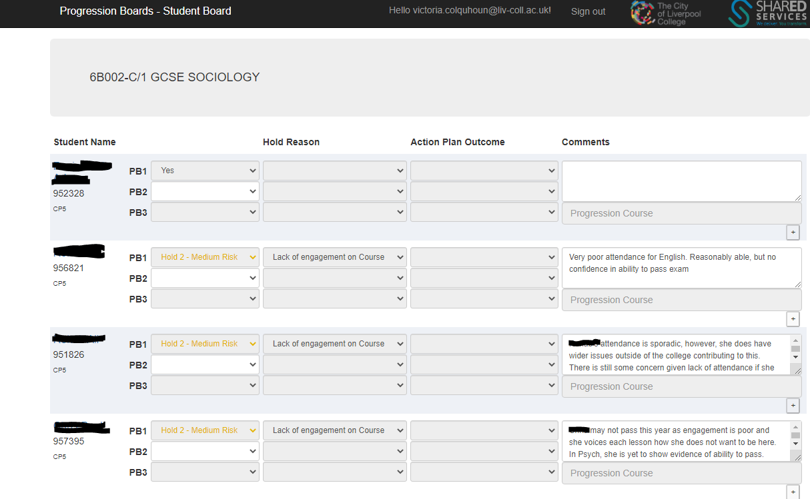

The outcomes for PB1 and PB2 are:
- Yes – Student is performing well and needs no intervention
  - Hold Green – No Risk – Student is performing well and will meet their target but needs support with stretching their outcomes.
  - Hold Amber – Medium Risk – Student needs intervention to ensure they pass their course and has the capability to meet or exceed target.
Hold Red – High Risk – Student is at a high risk of failing and previous interventions have had little impact.

During PB3 there are a wider range of options to be selected as this needs to outline the final progression decision. A course code will also need to be added in the progression course for each student who is a ‘Yes’.

Options for PB3
Yes – Student is progressing onto a course within college
No – Student is unable to progress to a course within the college
Hold – More information is needed for a decision to be made
Transfer – Student is transferring to a different school within college and interviews are needed to be held before a decision is made.
Positive Destination – Student is progressing to HE, Employment, Apprenticeship (etc.) outside of college.

All reports will be available in pro-monitor reports index and Power BI example below.

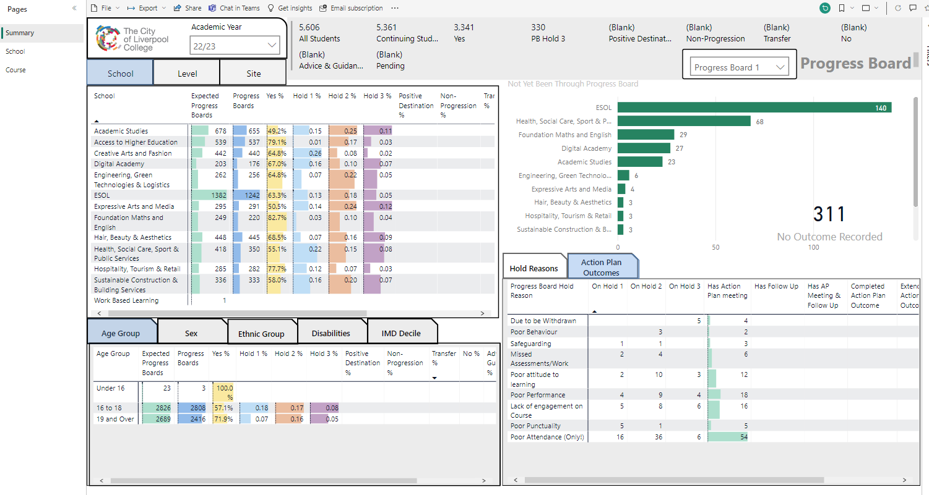

6.1 On Track Meeting (OTM)

If a student is not performing in college due to poor attendance, punctuality or working significantly below expected in their course (and the Progress Board Action Plan has not proven effective) an OTM meeting should be organised.

An OTM should follow on from the Progress Boards, where an Action Plan has been put in place but not all targets have been met and supportive interventions have not had a positive impact. There may be occasions aside from the Progress Board process, where an OTM is arranged when it is felt that a student is not making positive progress across all elements of their programme.

This is a formal meeting that is attended by:

  - Head of School/Dean of Academic Studies (or delegated substitute) – Chairs the meeting
  - Progress Leader/Tutor – brings the evidence of underperformance to the meeting for discussion
  - EHCP Coordinator (if the student has an EHCP)
  - Care Experience Lead (if relevant)
  - Parent/Carer or representative for that student (this could be Social Worker, Support Worker) should be invited
  - School Admin – note taker and impartial person (if available)
  - The student (an 18+ student may bring another representative with them should they wish to do so)

The student should be advised by the Progress Leader that an OTM will be arranged and the reasons why should be explained. This is recorded on Pro-Monitor as a meeting under the Student Performance category. Up to 5 working days’ notice must be given to allow for the School Admin team to arrange the OTM. In all cases consideration must be given as to the days a student attends college.
Letters notifying the student and parents/carers of the date and time of the meeting are sent from the School Admin team. Each admin team uses the same letter formats to ensure consistency

The meeting should follow the below format and be clearly recorded on ProMonitor.

- The Head of School/Dean chairs the meeting. It must be made clear during the introductions that this is a supportive College process to enable the student to get back On Track. The Head of School also makes clear that the process is a formal one which lasts for up to 4 weeks.
- The Progress Leader/tutor must provide supporting documentation at the meeting to support the issues raised, which may include attendance/punctuality data, subject/personal reports/ progression passport and/or group profile.
- The Head of School/ Dean ensures the parent/carer/external agents’ and the student’s views are listened to and documented. The student should feel supported to raise any concerns they have or any current issues they are facing that is impacting on their performance in College. This is to allow for individualised support to be offered and discussed. All information should be recorded in the meeting notes on pro-monitor and any external documents should be scanned in and added to the additional uploaded documents tab.
- The Head of School/Dean presents and explains the Action Plan Agreement (APA) and the SMART Targets set for the student, the date of the monitoring meeting is also set at this stage (4 weeks from the On Track meeting meeting).
- The Head of School must ensure that the student and parents/carers understand that failure to comply with the APA may result in the student being withdrawn from the programme.
- A copy of the APA is sent to both student and parents/carers, which clearly outlines the SMART targets and date/time of Monitoring Meeting.
- The quality of these meetings are reviewed in termly audits by the Head of Student Progress and feedback is given to all course managers.

6.2 The Monitoring Meeting

A Monitoring Meeting will take place at the end of the APA to review the targets set and decide on a n outcome, although the student and their progress should have been reviewed throughout the period of the APA also by curriculum staff and Progress Leaders. If the review highlights that withdrawal is necessary, the Progress Leader must arrange for the Head of School to be present at the Monitoring Meeting. A withdrawal can only be carried out by a Head of School.

If the student has an EHCP then the EHCP coordinator must be informed as to any possible withdrawal and the Care Experience lead must also be made aware for any care experienced students to ensure external stakeholders are informed.

The Monitoring Meeting may have one of three possible outcomes:

Outcome 1
The student has met the terms of the APA satisfactorily. In this case, the student is to be congratulated for getting back on track and informed that they are no longer subject to an Action Plan Agreement. The Progress Leader/tutor must inform the Subject tutors and the School Admin team, update the student [ILP] to enable the appropriate letter to be sent to the student and parents/carers.

If a student has satisfactorily met the terms of their APA they will continue to study on their programme, but if the student returns to the previous poor performance it is then appropriate to re-instate an APA (there may be additional targets to be set.) The Progress Leader will meet with the student to discuss this action and seek out any reason for not completing work / falling attendance, as required.
Normal processes for monitoring and reviewing the APA must be followed.

Outcome 2
The student has made significant efforts and achieved the majority of the targets set. In this instance, the APA can be extended for a further two weeks and another Monitoring Meeting is set.
After the second Monitoring Meeting the student is either released from the APA [as in Outcome 1] or a recommendation to withdraw the student from the course/College is made [Outcome 3]. A student can only have their APA extended once.

Outcome 3
The student has made very little or no effort to meet the terms of the APA, and following discussion it is unlikely the student will change their position or attitude. If this is the case the Progress Leader/tutor must discuss this with the Head of School/Dean of Academic Studies and Head of Faculty. The withdrawal can only be carried out by the Head of School

It is the responsibility of the Progress Leader/tutor following withdrawal of any 16-18 student through this process to inform the relevant parties, this could include parent/guardian, social worker, support worker and/or Virtual school. All students who are withdrawn will have an exit interview arranged for guidance and where possible, referrals to external agencies made. In addition, for any 16-18 year-old students, the Local Authority must be contacted.

The Progress Leader must inform the appropriate School Administrator so they can send the appropriate letter to the student and parents/carers. Update all profiles and ensure that a Change Request is completed to withdraw the student from their course/Study Programme.

6.3 Failure to attend an On Track Meeting

If a student fails to attend their On Track meeting, a letter will be sent advising of an alternative date. This must be within 1 week of the original date [excluding exceptional circumstances]. If the student fails to attend two arranged On Track meeting dates set, without significant reason, they will not be able to appeal and will be put forward for withdrawal. [See Outcome 3 above for process] Same actions to follow.

Appeals Procedure for On Track Meeting

The student has a right of appeal against withdrawal from the College, by written notice in a formal letter to be sent to the Director of Personal Development and Progression either by email or post with grounds for their appeal, within 7 days of receipt of written notice of the outcome of the Monitoring Meeting. An appeal panel will be convened consisting of the Director of Curriculum or Director of Personal, Development and Progress, Head of Student Progress and a staff member familiar with the programme but not the case. A member of the School Administration team may also attend to take notes.

The student will be invited to present their case with evidence and can be accompanied by a parent/carer or friend. All parties should be sent copies of all documentation.

The Director of Personal Development and Progress will advise the student of the outcome of appeal verbally and in writing.

7. Special Consideration

Taking the individual student’s personal circumstances into consideration and at the discretion of the Head of School/Dean of Academic Studies, special consideration may be made for certain students regarding the implementation of On Track Meeting procedures. This could be for students with an EHCP and/or additional learning needs, for students who are known to and being supported by our safeguarding and wellbeing teams, care experienced students and those enrolled on courses at Level 1 or below. An alternative approach may be deemed more appropriate where the On Track Meeting is attended by a Progress Leader and/or member of Support staff who will represent the College solely, meeting with parent/carer and student [and external agent supporting the student/family if relevant]. Meetings and communication should still be recorded in the same way via ProMonitor, targets be closely monitored and reviewed and communication with all relevant stakeholders be made. If special consideration has been given, the student will still be subject to the same outcomes if they fail to meet the terms of the APA, following 4 weeks of support.

8. Vulnerable Students

The Progress Leader must consult with the Head of Additional Learning Support and/or the Safeguarding, Mental Health & Well-being Manager regarding any students, irrespective of whether the student is failing to maintain academic standards, who may be considered to be ‘Vulnerable’ (or experiencing a significant level of personal, emotional trauma or stress). If the student is deemed to be ‘Vulnerable’ the Student Performance Policy may be customised [or less formal – see above] to meet with the circumstances of the student. This must be discussed in advance with the Heads of Student Progress and the Head of School/Dean of Academic Studies and discretion applied. Again, as with any special consideration and discretion applied, meetings and communication should still be recorded in the same way via ProMonitor, targets be closely monitored and reviewed and communication with all relevant stakeholders be made. If special consideration has been given, the student will still be subject to the same outcomes if they fail to meet the terms of the APA, following 4 weeks of support

9. Key Roles and Responsibilities

